(Academic Article Template )

Title (English) (Times New Roman, 14 pt, Bold)

Name A. Surname¹ , Name B. Surname² and Name C. Surname^{1,2,*}
¹ University Name, Department Name or Institute, State, Country
² (Other) University Name, Department Name or Institute, State, Country
³ (Other) University Name, Department Name or Institute, State, Country
*Corresponding author: e-mail (Times New Roman, 12 pt, Regular)

Abstract (Times New Roman, 14 pt, Bold)
(Abstract content in English, Times New Roman, 12 pt, Regular)
............................................................................................................................................................ ............................................................................................................................................................ ............................................................................................................................................................ ............................................................................................................................................................ ........................................................................................................................................................................................................................................................................................................................ ............................................................................................................................................................
Keywords: (Times New Roman, 14 pt, Bold)
Keywords— First word or key phrase, second word or key phrase, third word or key phrase. (Place between three and six key words or phrases separated by a comma, which represent the theme of your work) ............................................................................................................................................................

Introduction
(Times New Roman, 14 pt, Bold)
................................................................................................................................................ .................. (Content in Times New Roman, 12 pt, Regular) .............................................. ........................................................................................................................................................................................................................................................................................................................................................................................................................................................................................................................ ................................................................................................................................................
................................................................................................................................................

Methodology
(Times New Roman, 14 pt, Bold)
.................................................................................................................................................................. (Content in Times New Roman, 12 pt, Regular) .............................................. ................................................................................................................................................................................................................................................................................................................................................................................................................................................ ................................................................................................................................................
................................................................................................................................................ ........................................................................

Results and Discussion (Times New Roman, 14 pt, Bold)
........................................................................................................................................................................................................................ .................. (Content in Times New Roman, 12 pt, Regular) .............................................. .............................................................................................................................................................................................................................................................................................. ................................................................................................................................................................................................................................................................................................
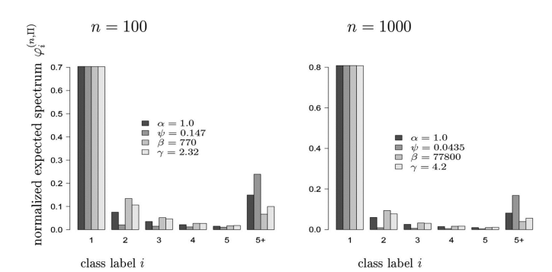
Figure 1 Example figure from………
Conclusion (Times New Roman, 14 pt, Bold)
.......................................................................................................................... .................. (Content in Times New Roman, 12 pt, Regular) .............................................. .......................................................................................................................... .......................................................................................................................... ..........................................................................................................................
Acknowledgements (Times New Roman, 14 pt, Bold)
................................................................................................................................................................................................................................................................................................ .................. (Content in Times New Roman, 12 pt, Regular) .............................................. ................................................................................................................................................
References (Times New Roman, 14 pt, Bold)
................................................................................................................................................ .................. (Content in Times New Roman, 12 pt, Regular) .............................................. ................................................................................................................................................ ................................................................................................................................................

Table 1: Example table from ……
Student | Score | Grade | Notes
A | 85 | A | Performed very well.
B | 76 | B+ | A good attempt

APA 7 Reference Template

1. Journal Article
Template:
Author, A. A., Author, B. B., & Author, C. C. (Year). Title of the article. Journal Name, Volume(Issue), page–page. https://doi.org/xxxxx
Example:
Smith, J. A., & Brown, R. T. (2023). Development of plant-based protein products. Journal of Food Science, 45(2), 123–135. https://doi.org/10.1016/j.jfood.2023.01.001

2. Conference Paper (Published in Proceedings)
Template:
Author, A. A., & Author, B. B. (Year). Title of paper. In Editor, E. E. (Ed.), Proceedings Title (pp. xx–xx). Publisher. https://doi.org/xxxxx
Example:
Wong, K., & Lee, M. (2022). Innovation in herbal product development. In P. Tan (Ed.), Proceedings of the International Conference on Sustainable Agriculture (pp. 45–52). Springer. https://doi.org/10.1007/978-3-030-00000-0

3. Conference Paper (Unpublished / Presented Only)
Template:
Author, A. A. (Year, Month). Title of paper. Paper presented at the Conference Name, Location.
Example:
Chaiyaporn, S. (2024, March). Value-added products from Wolffia globosa. Paper presented at the International Conference on Food Innovation, Bangkok, Thailand.

4. Book
Template:
Author, A. A. (Year). Book title (Edition). Publisher.
Example:
Creswell, J. W. (2018). Research design: Qualitative, quantitative, and mixed methods approaches (4th ed.). Sage Publications.

5. Book Chapter
Template:
Author, A. A. (Year). Title of chapter. In E. E. Editor (Ed.), Book title (pp. xx–xx). Publisher.
Example:
Johnson, L. M. (2021). Advances in plant biotechnology. In R. Green (Ed.), Modern agricultural science (pp. 78–95). Academic Press.

6. Thesis / Dissertation
Template:
Author, A. A. (Year). Title of thesis (Master’s thesis/Doctoral dissertation). University Name.
Example:
Phonchai, T. (2022). Nutritional analysis of Wolffia globosa (Master’s thesis). Mahasarakham University.

7. Website
Template:
Author/Organization. (Year). Title of webpage. Website Name. URL
Example:
Food and Agriculture Organization. (2021). Edible aquatic plants. FAO. https://www.fao.org

8. Report
Template:
Organization Name. (Year). Title of report. Publisher (if different). URL
Example:
World Health Organization. (2020). Healthy diet guidelines. https://www.who.int

Review and Evaluation of Manuscripts
Submitted manuscripts will be reviewed and evaluated through a peer review process by at least two qualified reviewers from both within and outside the university in the relevant field of study. The editorial board will notify authors of the review results via the email address provided in the submission system through the registered user account.

Publication Policy for Conference Proceedings
Manuscripts submitted for publication in the conference proceedings must not be plagiarized from previously published works and must not have been published in any journal or other publication prior to submission.
The copyright of accepted and published manuscripts shall be held by the Research and Development Institute, Rajabhat Mahasarakham University. No part or entirety of the manuscript may be reproduced without proper written citation.
The authors are solely responsible for the content of their manuscripts published in the International Conference on Science and Social Sciences of Rajabhat Mahasarakham University. The responsibility does not extend to any errors arising from typesetting or printing processes.

